Intercalifornias Project Proposal
Amanda Mei Kim
amandameikim@gmail.com
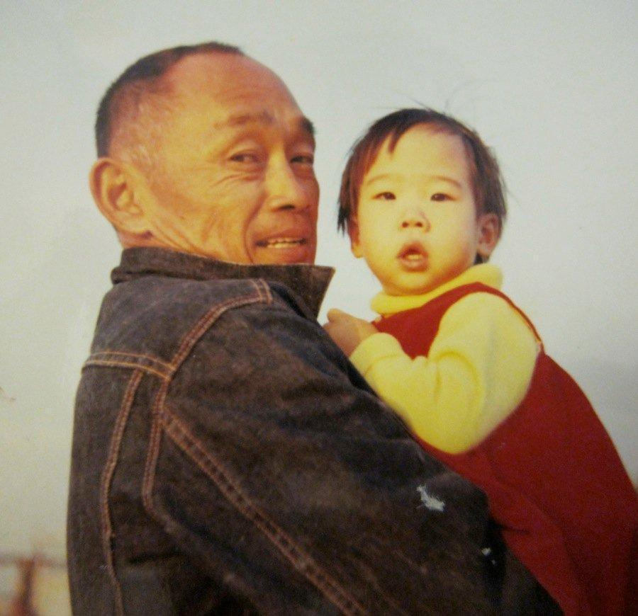

My father (age 46) and I (age 8 months) on the 200 acres of farmland that he rented in Saticoy, California. Our whole family produced a profit for the landlord for 28 years, until we were evicted when he was 74.

OVERVIEW
Intercalifornias is a memoir-in-essays that uses a vertical history technique to explore how and why events occur in the lives of poor rural Californians of color. What causes cycles of poverty and violence? How does striving or taking risks disadvantage poor people of color? Each essay is organized around a single theme like family detention, education, missing girls, and van life, and demonstrates how the labor, ideas, energy, and investments of rural families of color get eaten up by racist capitalist systems. This memoir also explores how people build power and resilience in themselves and their communities, and across racial and ethnic lines.
Through these essays, I explore four generations of my family’s history as Asian American agricultural workers. Every generation reached for the American Dream, but never quite made it due to harassment, exploitation, incarceration, and even murder. Their story is part of a larger pattern of racial capitalism in California, beginning with the Native Californians who were enslaved by missionaries to the modern-day trafficking of Mixtecos and other indigenous Americans. California's $50 billion per year agricultural industry has always depended on structural racism. Examples of this cycle of exploitation abound. In 1928, a Chinese American farmer was not allowed to own water rights and today, Hmong American farmers are banned from trucking water onto their lands. Ownership and self-determination remain elusive for rural people of color in California and beyond.
I document the labor, collaboration, and ingenuity that immigrants and people of color have used to survive in rural California, the foods we have brought to white tables, and our role in an increasingly fragile food system and natural environment.
I tackle difficult, even horrific, topics--from poisoned water supplies and land seizures to child abductions and racial hierarchies in the slaughterhouse industry--but I do it with tenderness, intimacy, and a sense of responsibility to the subjects and readers. My goal is to create a visceral experience that leaves readers with an emotional understanding of the full cost of the food on their plates. Readers will experience the joy, the cruelty, the damage, and the love that holds rural communities of color together; have a mental map of the systems (educational, food, water, and more) that bind us together, producing pain for some and pleasure for others. By the end of the book, readers will know what it feels like to be evicted, to sell their family treasures, to live in a mobile home on the edge of a river, and to rejoin the workforce as seniors. They will know that somewhere on their map, is a child sleeping in a van, a man wearing a pesticide-soaked shirt, a woman who spends her days picking up trash, and her nights caring for strangers.
This is not a nostalgic elegy to the rural past; it is a charge to end cycles of economic violence and exploitation against rural people of color today and to invest in the sustainable and healthy food system that we deserve. It is the story of four generations of systemic racism and violence, and my family’s and my community’s resistance.
I also offer a vision of hope and sustainability by spotlighting small farmers of color, who, against all odds, remain the best caretakers of California's farmlands; and the key role that Indigenous people--Hmong American farmers, Mixteco and other Mayan farmworkers from Mexico, and Native Californians--have in rebuilding a healthy and sustainable food system.

To date, two essays from this collection have been published and a third is forthcoming in Brick Literary Journal. In 2022, an excerpt will be anthologized in Nonwhite and Woman from Woodhall Press.
The first essay, "Van Life" (attached) was first published in Brick Literary Journal in December 2020 and republished in LitHub in January 2021. It is about my Japanese- and Korean-American farming family and the ways that music, mental health, environmental racism, and vans thread through our lives. The essay was promoted by Alexander Chee who tweeted, “Really loved this from @amandameikim, and if there's a way for it to expand into a full-length book, I would be thrilled.” It will be taught in Jung Yun’s Creative Nonfiction class at George Washington University and Erica Lorraine Webb’s writing class at Ohlone College. It was also nominated for a Pushcart Prize.
The second essay, "Vernon on the Water" (PANK, April 2021) was selected by Aram Mrjoian for a special environmental futures folio. Through vignettes about slaughterhouses, tools, the geography of Southern California, interracial love, and interracial violence--it describes generations of environmental racism, which has evolved into a brutal food system. I also offer a sustainable alternative to this system, which is to produce dignity for people and the land. The essay was promoted by Hyo Yoon Kang who tweeted, "Woke up still thinking about this essay. It gives a deeper understanding of our current state than any abstract theories of anthropocene, post/more than human, and class and race. All in mindblowingly beautiful writing." Literary agent Akin Akinwumi tweeted, “If you're looking for reading material this weekend, I'd highly recommend @pankmagazine's Environmental Futures Folio edited by @AMrjoian575. I was blown away by many of the pieces, including the essay "Vernon on the Water" by Amanda Mei Kim.”
I have completed the first draft of a book proposal and submitted it to five agents. Three requested minor edits, mostly to scale back the story and incorporate more food history, which I’m happy to do. I’m still waiting to hear back from the other two.
This workshop is an ideal fit for me because I’m a motivated writer with forty pages of this project written and a generous reader who believes that writers of color have the collective power to transform, not just the content of stories, but their structures and forms. Through my writing, I’m remapping our connections to history and nature, and I know that other writers of color are bridging huge chasms as well. I have a deep sense of empathy for writers of color and will work to make sure we all cross the line together.

BIOGRAPHY
Amanda Mei Kim is a fourth-generation Californian of Japanese and Korean descent, who grew up on a small tenant farm in Saticoy, California, a town with a 50% high school dropout rate. She graduated from Brown University (Bachelor of Arts, American Studies) where she led the university’s first Asian-American writing class, and San Francisco State University (Master of Fine Arts, Creative Writing).
She has worked on two oral history projects: a history of farmworkers in Ventura County (UCLA) and the history of health science (UCSF).
Amanda received the James D. Phelan Literary Award and was a semi-finalist for the Heekin Award in the Novel. Her essay Van Life was nominated for a Pushcart Prize. She was awarded residencies at Hedgebrook, the Fine Arts Work Center, and Yefe Nof. She completed VONA and the Grotto’s Rooted and Written workshops. Natalie Baszile, Lidia Yuknavitch, Ursula K. LeGuin, Roberto Lovato, Reyna Grande, and Nathalie Handal all selected her for their intensive workshops. Her work has been published in PANK (2021), Tayo Literary Magazine (2019), Brick Literary Journal (2020), and republished on Literary Hub (2021). She has nonfiction pieces forthcoming in Brick Literary Journal and an anthology of BIPOC women writers from Woodhall Press (2022).

